Dominic Drury

11/28/2023

CS-340

6-1 Milestone: Dashboard Data Visualizations

the interactive data table populated with the Austin Animal Center Outcomes data from MongoDB

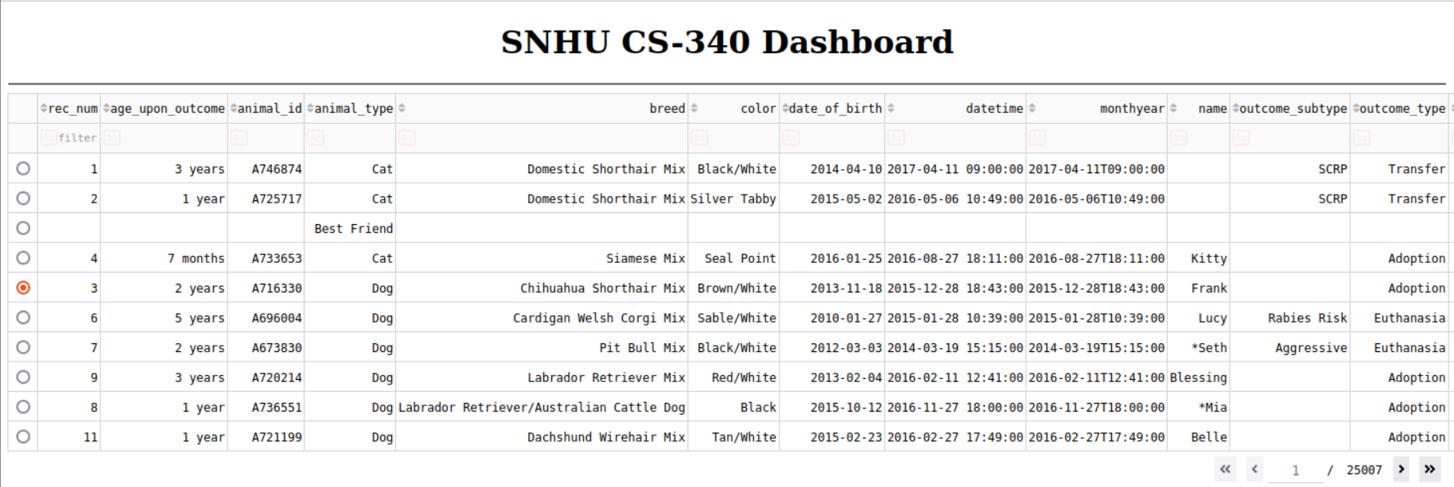

geolocation chart showing the location of the first dog in the table

